OOPS LAB

Experiment -2

NAME- ANMOL YADAV SAP ID- 500083814 ROLLNO- R214220178

**Question: 1**

1. Write a program to find the largest of 3 numbers.

Code:-

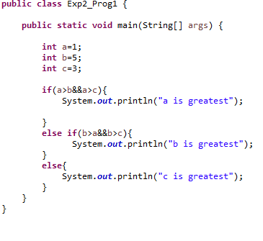

**Output:-**

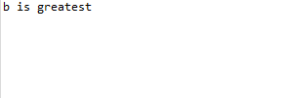

**Question 2:**

Write a program to implement a command line calculator.

**Code:**

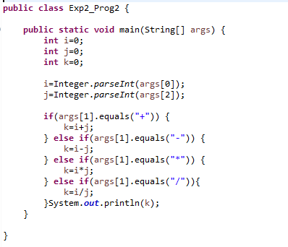

**Output:-**

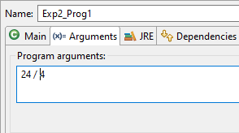



**Question: 3**

Write a program using classes and object in java.

**Code:**-

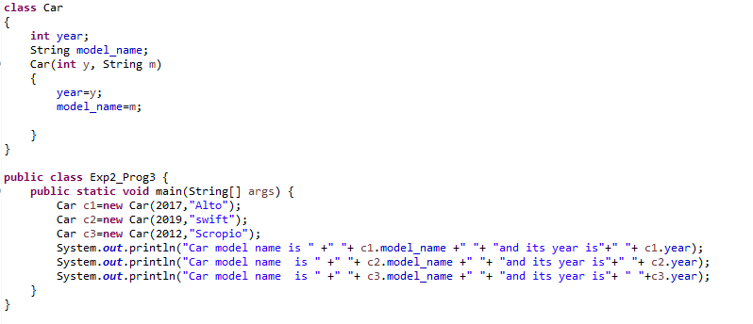

**Output:-**

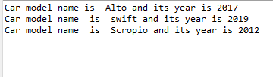

**Question : 4**

Write a program to accept 10 student’s marks in an array, arrange it into ascending order, convert into the following grades and print marks and grades in the tabular form.

Between 40 and 50 : PASS Between 51 and 75 : MERIT and above : DISTINCTION

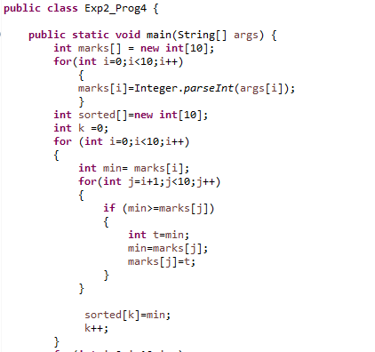

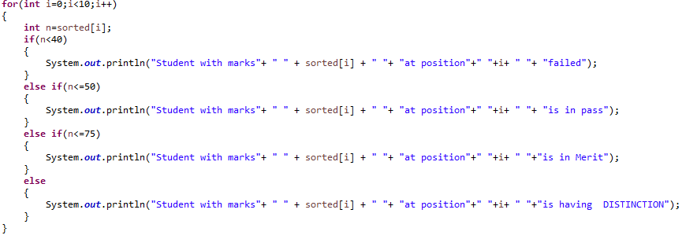

**Output:-**

